STAT 43000/STAT 53001 Applied Statistics Spring 2023

Lab-2

**Q. N. 1)** In a medical study, researchers collected measurements from 25 young children. Of interest is the dependency of the plasma level of a polyamine on age.

|  |  |  |
| --- | --- | --- |
| Child | Plasma | Age |
| 1 | 13.44 | 0 |
| 2 | 12.84 | 0 |
| 3 | 11.91 | 0 |
| 4 | 20.09 | 0 |
| 5 | 15.60 | 0 |
| 6 | 10.11 | 1 |
| 7 | 11.38 | 1 |
| 8 | 10.28 | 1 |
| 9 | 8.96 | 1 |
| 10 | 8.59 | 1 |
| 11 | 9.83 | 2 |
| 12 | 9.00 | 2 |
| 13 | 8.65 | 2 |
| 14 | 7.85 | 2 |
| 15 | 8.88 | 2 |
| 16 | 7.94 | 3 |
| 17 | 6.01 | 3 |
| 18 | 5.14 | 3 |
| 19 | 6.90 | 3 |
| 20 | 6.77 | 3 |
| 21 | 4.86 | 4 |
| 22 | 5.10 | 4 |
| 23 | 5.67 | 4 |
| 24 | 5.75 | 4 |
| 25 | 6.23 | 4 |

1. Fit a simple linear regression model.

1. Use Box-Cox transformation to choose appropriate value of λ.

1. Fit a simple linear regression model after transformation.

1. Compare and contrast Models in (1) and (3).

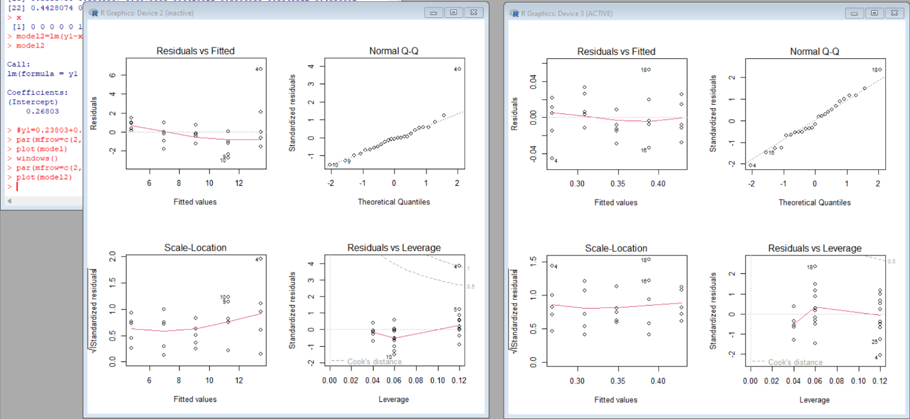

The transformation reduce the scale and the difference between the data.